**Course Work Answer Book**

**UNIVERSITY COURSE WORK**

|  |  |  |  |  |  |  |  |  |  |  |  |  |  |  |  |
| --- | --- | --- | --- | --- | --- | --- | --- | --- | --- | --- | --- | --- | --- | --- | --- |
| REGISTRATION NUMBER | | | | | | | | | VU-BIT-2109-1328 | | | | | | |
| Title of The Program (eg BBA, BSC, BPH, BSWA) | | | | | | | | | | | | | BIT | | |
| Bachelor of Information Technology | | | | | | | | | | | | | | | |
| Department | | | | Other Depts in Faculty of Science and Technology | | | | | | | | | | | |
| Faculty | Faculty of Science and Technology | | | | | | | | | | | | | | |
| Year Of study (YrI , YrII, YrIII, or YrIV) | | | | | | | | | | | 3 | | | | |
| Module Code and Name | | | | | | | 1204 FST | | | | | | | | |
| Object Oriented Programming | | | | | | | | | | | | | | | |
| Semester | | | 2 | | | | | | | | | | | | |
|  | | | | | | | | | | | | | | | |
| Retake: | | Yes | | |  | | | No | |  | | (Tick whichever is applicable) | | | |
| Date of Course Work | | | | | | Tue May 21 2024 11:22:00 GMT+0300 (East Africa Time) | | | | | | | | | |
|  | | | | | |  | | | | | | | | | |
| **DIRECTIONS TO CANDIDATES (Turn to page ii for more instructions).** | | | | | | | | | | | | | **FOR USE BY EXAMINERS ONLY** | | |
| **Question Number** | **Internal Examiner** | **External Examiner** |
| 1. Leave margin blank. 2. Begin each answer on a fresh page. 3. Write the number of each question and theCandidate's Number at the top of each page. 4. Write the numbers of the questionswhich you have attempted, with subsections where necessary, in the spacesprovided below | | | | | | | | | | | | |
|  |  |  |
|  |  |  |
|  |  |  |
|  |  |  |
|  |  |  |
|  |  |  |
|  |  |  |
|  |  |  |
|  |  |  |
|  |  |  |
|  |  |  |
|  |  |  |
|  |  |  |
|  |  |  |
|  |  |  |
| **TOTAL** |  |  |

|  |  |  |  |  |  |  |  |  |
| --- | --- | --- | --- | --- | --- | --- | --- | --- |
| **NUMBER OF QUESTIONS** you have answered in the order in which you have written them | | | | | | | | |
|  |  |  |  |  |  |  |  |  |

**How and where should I submit my Course Work script?**

Every student will be required to submit their Course Work via [VClass Students Portal](https://vclass.ac/) E.g. you go to [www.vclass.ac](http://www.vclass.ac) and login, to your account, then on the left sidebar menu **click on Course Work**.

Under Course Work you will see the following: -

1. Instructions for that particular Course Work with time required to finish your Course Work as per instructions,
2. A student will be required to download the question paper and the answer sheet provided by the university within the same module Course Work, or a student can be required to attempt structured questions within the system depending on how the Course Work was set.
3. Submission of answered questions is done,
4. Student is required to click to **consent** to show that the answered Course Work belongs to them.
5. **Note** that if Course Work is for download, a student will be required to download the question paper and answer sheet, do their Course Work within the given stipulated time.
6. Required to scan and upload back the answered booklet through the same portal as per format available.
7. Course Work uploaded will directly be received by the Registry department.
8. Students here are required to use [VClass e-Learning system](https://vclass.ac)for all Course Work and for any failure they can contact the Registry department for guidance.
9. No late submission will be accepted.

**Avoid any malpractice because this will attract severe penalties such as invalidating the answered script whose consequences will attract retakes.**

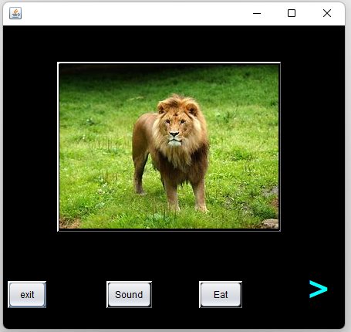Subclass LION output.

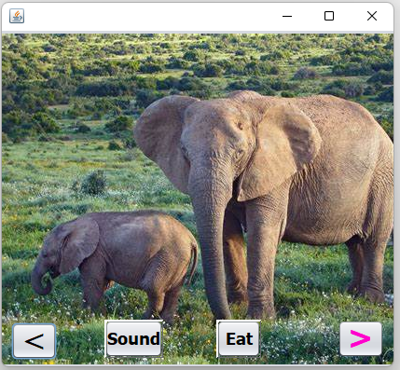

Elephant subclass output

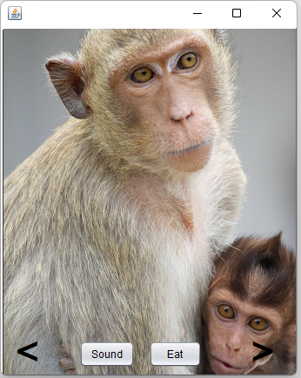Monkey subclass output

**QUESTION TWO.**

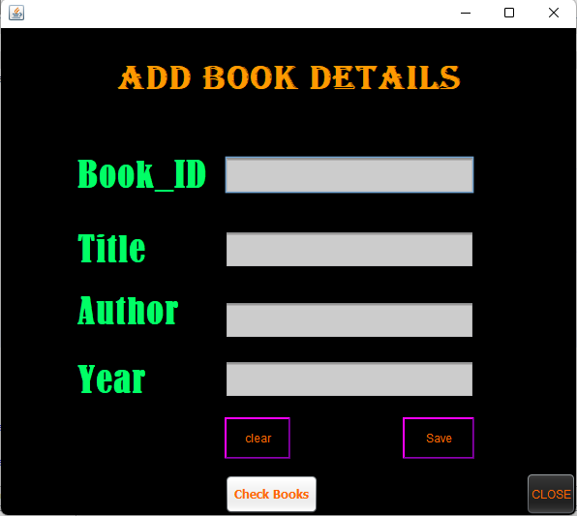

Above is the add books were i can add new books into the database.

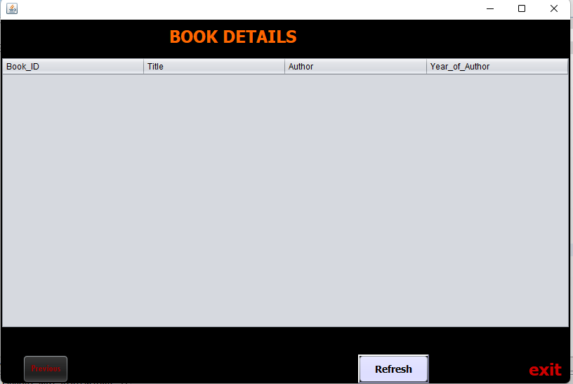

This page enables me to view all books existing in the system.

By clicking the refresh button, all book records populate on the jtable.

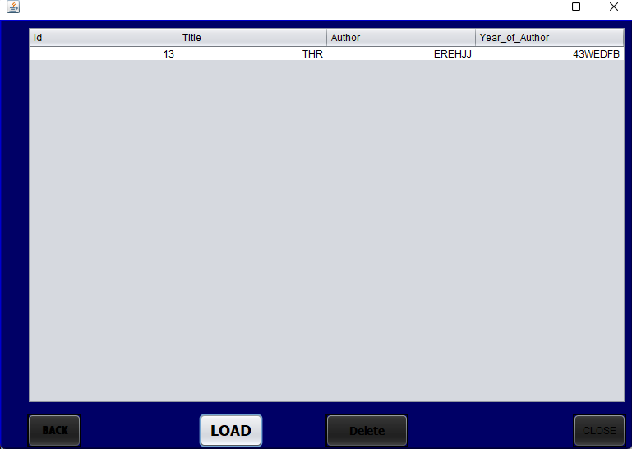

Here, book records in existence can be deleted as shown below.